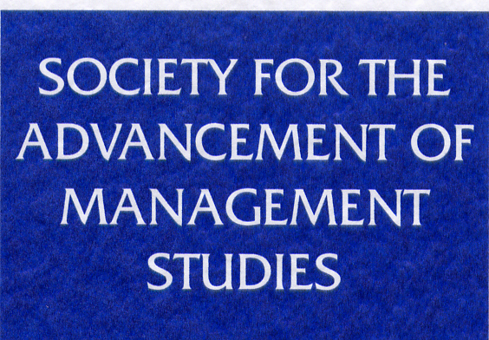
DEVELOPING THE MANAGEMENT STUDIES COMMUNITY
FUNDING APPLICATION FORM
When completing this form please pay special attention to the following:

- Ensuring that you clearly illustrate how SAMS funds will be used to achieve demonstrable benefits to the management studies community.

- If this is an application for repeat funding, please ensure you provide evidence of the impact of SAMS funding on your previous event.

- Identifying the specific benefits for doctoral students and/or early career academics (i.e. academics within the first two years of an appointment).

- Where other sources of funding, if any, will be obtained. (SAMS normally expects to part-fund activities to a maximum of £10,000.)

- An explanation of the purpose and content of the workshop or event. (NB: funds will not be made available for research projects, individual pieces of research, conference attendance, or staff costs.)
The deadline for the latest round of applications is 16:00 GMT on Friday, 13th January 2017. Proposals received after the closing date cannot be considered until the next round.
Informal enquiries are welcome to Margaret Turner, SAMS Administrator: business.sams@durham.ac.uk

- Details of main applicant
Name | Email | Telephone

- Title of the event / programme

- Details of the event / programme. Please include date, venue, any confirmed speakers, target audience, etc. No more than 750 words.

- Please list benefits to the international business and management academic community (with particular emphasis on doctoral students and early career academics). No more than 750 words.

- Please state the approximate/expected number of beneficiaries in each category.
Doctoral Students
Early career academics
Other business and management academics
Others – please state

- Please provide details of timescales and plans and indicate what has already been done. No more than 750 words.

- Please provide an outline budget and indicate the total cost of the event, how much you are requesting from SAMS, and exactly what it will be spent on. No more than 750 words.
- Please provide details of other funding and indicate whether it is applied for or has already been obtained. No more than 750 words.

- Please list other partners and, if their involvement is not financial, please list the contribution they will make. No more than 750 words.

- Please use this box for any other information you wish to provide in support of your application.

Thank you for completing this form.

Please email applications to Margaret Turner (business.sams@durham.ac.uk) by 16.00 GMT by the Friday, 13th January 2017.

