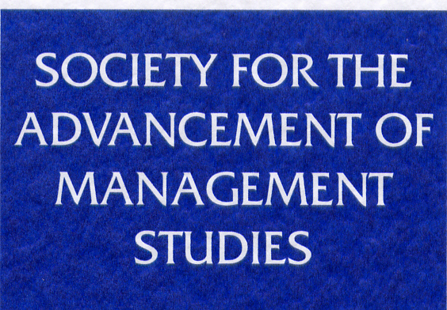

DEVELOPING THE MANAGEMENT STUDIES COMMUNITY
FUNDING APPLICATION FORM

SAMS (The Society for the Advancement of Management Studies) invites applications for funding to support events or activities that benefit the management studies community.

Please note that these funds are for specific costs directly related to organisation of workshops and events, whether they take place in-person or virtually. They are not to fund research projects, individual pieces of research, the creation of websites, technical hardware, or staff costs or salaries in any form, including fees or honoraria for speakers or instructors. Applicants should provide their current institutional affiliation as payments will only be made to an institutional account or research fund, not to a personal account.

We will consider applications for repeat funding in exceptional cases only, therefore if this is an application for repeat funding, please ensure you provide evidence of the impact of SAMS’ funding on your previous event.

Priority will be given to proposals that contribute to the development of doctoral students and/or early career academics. Please provide an explanation of the purpose and content of the workshop or event and, when completing the application form, please make clear how SAMS’ funds will be used and how they will result in demonstrable additional benefits to the management studies community. Please ensure that you identify the specific benefits for doctoral students and/or early career academics (i.e. academics within the first two years of an appointment).

SAMS normally expects to fund to a maximum of £10,000, but most awards are significantly less than this, therefore it is expected, though not required, that there should be other sources of support. Examples of previous awards can be found here.

The deadline for the latest round of applications is 16:00 BST on Friday, 5th April 2024. Proposals received after the closing date will not be considered until the next round.

Informal enquiries are welcome to Margaret Turner, SAMS Administrator: business.sams@durham.ac.uk
Details of main applicant
Name: Click here to enter text.
Institutional Affiliation: Click here to enter text.
Email address: Click here to enter text.
Telephone no.: Click here to enter text.

Title of the event:
Click here to enter text.

Description of the event. Please include date, venue, any confirmed speakers, target audience, etc. No more than 750 words.
Click here to enter text.

Please state the approximate/expected number of beneficiaries in each category.
Doctoral Students: Click here to enter text.
Early Career Researchers: Click here to enter text.
Other Business & Management Academics: Click here to enter text.
Others (please state): Click here to enter text.

Please list the benefits to the international business and management academic community, with particular emphasis on doctoral students and early career academics. No more than 500 words.
Click here to enter text, e.g. developing papers for publication in top journals, etc.

Please provide details of timescales and plans and indicate what has already been done. No more than 750 words.
Click here to enter text, e.g. keynotes to be invited by end of summer term, etc.

Please provide an outline budget and indicate the total cost of the event, how much you are requesting from SAMS, and exactly what it will be spent on. Please amend the spreadsheet as needed to provide details.

Item | Details | Amount requested from SAMS | Amount from other funding sources
Event catering
Student bursaries
Travel & accommodation expenses
Venue costs
Marketing costs
Other
Other
TOTAL EVENT COST | 0
OF WHICH SAMS CONTRIBUTES | 0

*Please note that SAMS will not cover the following costs:
- Staff costs, salaries, fees, or honoraria
- Research projects, or individual pieces of research
- Technical hardware, or the creation of websites
- Branded marketing materials from the host institution
- Lecture/seminar room hire at the host institution
- Events solely open to attendees of the host institution

Have you applied for, or received, funding for this event from other source(s)? Choose an item.
If yes, please give details of the other funding source(s): Click here to enter text.

Please list any other partners and, if their involvement is not financial, please list the contribution they will make. No more than 750 words.
Click here to enter text, e.g. host institution providing venue free of charge, etc.

Have you previously received SAMS funding? Choose an item.
If so, please give the title and date of the successful event:
Click here to enter text, e.g. Management Student Development Workshop, November 2015

Please use this box for any other information you wish to provide in support of your application.
Click here to enter text.

Thank you for completing this form.

Please email applications to Margaret Turner (business.sams@durham.ac.uk) by 16:00 BST by the Friday, 5th April 2024.

