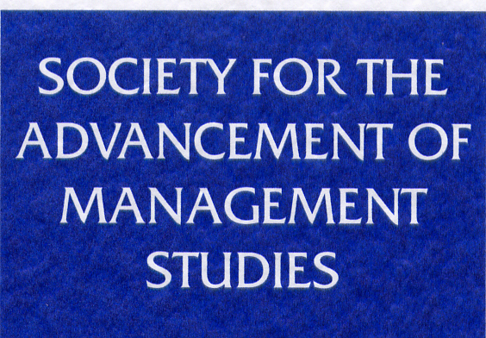

Grigor McClelland Doctoral Dissertation Award
Application Form

The Grigor McClelland Doctoral Dissertation Award is an annual prize of £5,000 awarded to innovative scholarship demonstrated within a PhD or DBA thesis in any discipline within management and organisation studies. The award is supported by the Journal of Management Studies (JMS) and the Society for the Advancement of Management Studies (SAMS), a charitable organisation which supports capacity building in business and management research.

Grigor McClelland was the founder of SAMS, the founding editor of JMS, and the founding Director of Manchester Business School.

By submitting your application form and documents, you are confirming that you are eligible to apply for the Grigor McClelland Doctoral Dissertation Award 2020.

Details of applicant
Name: Click here to enter text.
Email address: Click here to enter text.
Awarding Institution: Click here to enter text.
Current Institution (if different from the above): Click here to enter text.

Title of dissertation:
Click here to enter text.

Co-author(s) (if any):
Click here to enter text.

Date PhD/DBA awarded and formal examination process concluded: Click here to enter text.

Please use this box for any other information you wish to provide in support of your application.
Click here to enter text.

Application Checklist

I confirm that my thesis is an independent and original piece of work.

I understand that, if I am selected as a finalist for the Grigor McClelland Doctoral Dissertation Award and am not able to attend the Award event to deliver my presentation, I forfeit my place as a finalist and will no longer be considered for the Award.

I consent for my photo to be taken at the Award event if I am selected as a finalist for the Grigor McClelland Doctoral Dissertation Award, and that it may be used for promotional material such as, but not limited to, the SAMS website, social media and leaflets.

Failure to confirm all of these requirements as part of your application will exclude it from consideration for the Grigor McClelland Doctoral Dissertation Award.

Thank you for completing this form.

Please email applications to Joanne Cheseldine (business.sams@durham.ac.uk) by 16:00 GMT by 28th February 2020.

